INFLUX:

1. Time series:
- A sequence of data points, typically consisting of successive measurements, made from a same source over period of time.
- One of the dimensions of the Time series data is always time.
- Data spread across a time stamp.
- Data is stored in ‘collections’ but those collections share a common denominator: they are aggregated over time. This means that every point we are able to store should have a time stamp associated with it.
- Like temperature in a day at different times
- We generally use this time series data to find the difference in the values based on time period.

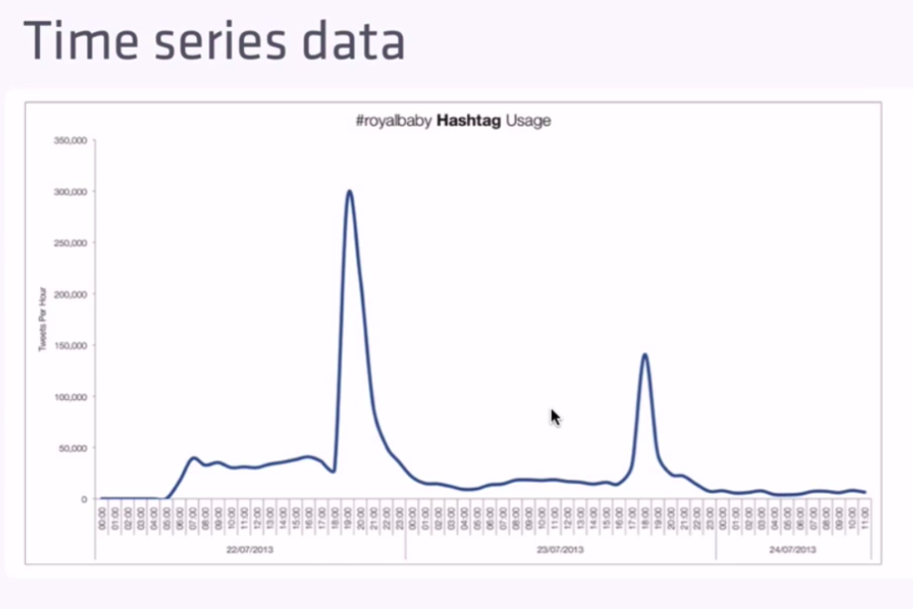

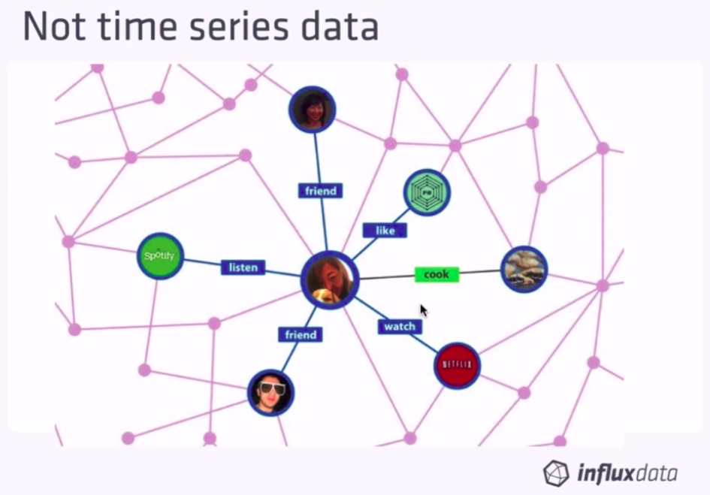

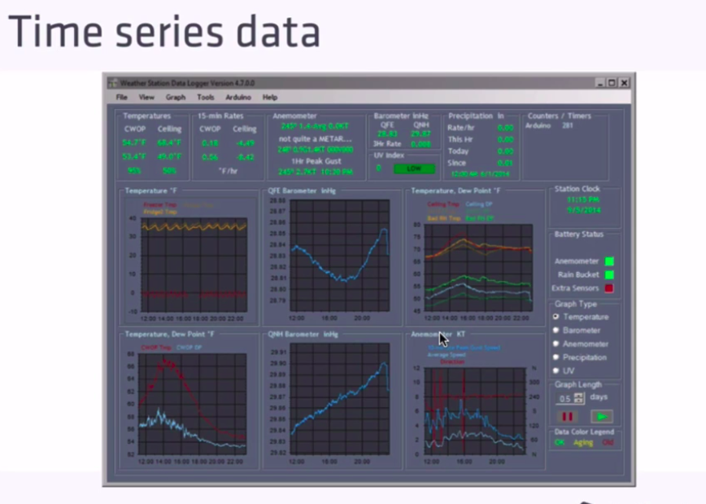

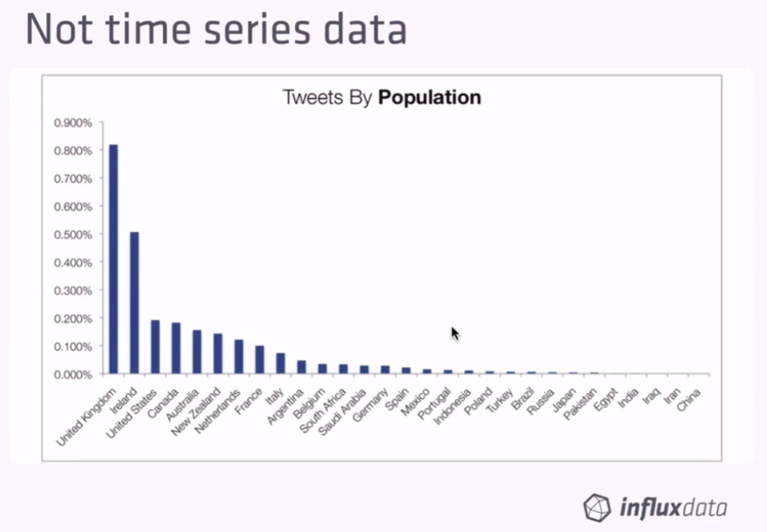

2. Regular and Irregular Time Series:
- Regular time series or Metrics happen at the regular interval time. Here we know exactly when the data is going to come in.
- Irregular or Events – Here we don’t know when the data is going to come in. But we do know that its going to come in.

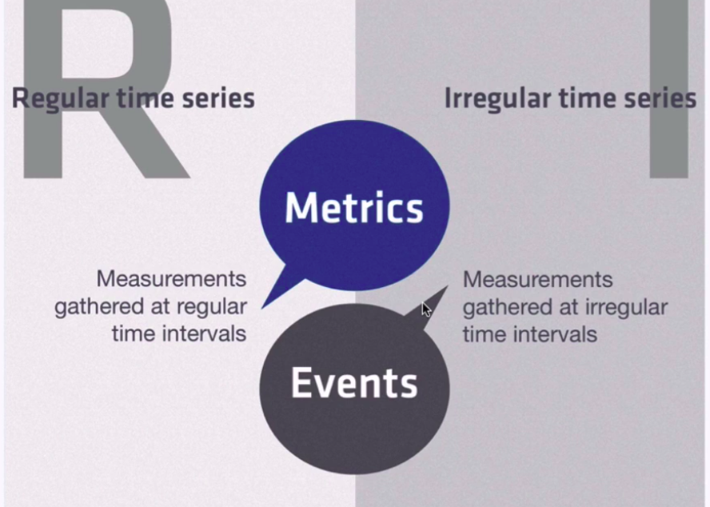

- The summarization of data helps in doing some forecasting. For example, we may be getting some Events(irregular) Stock data, but we can do something like get the average traded price over the last time minutes of the trade.
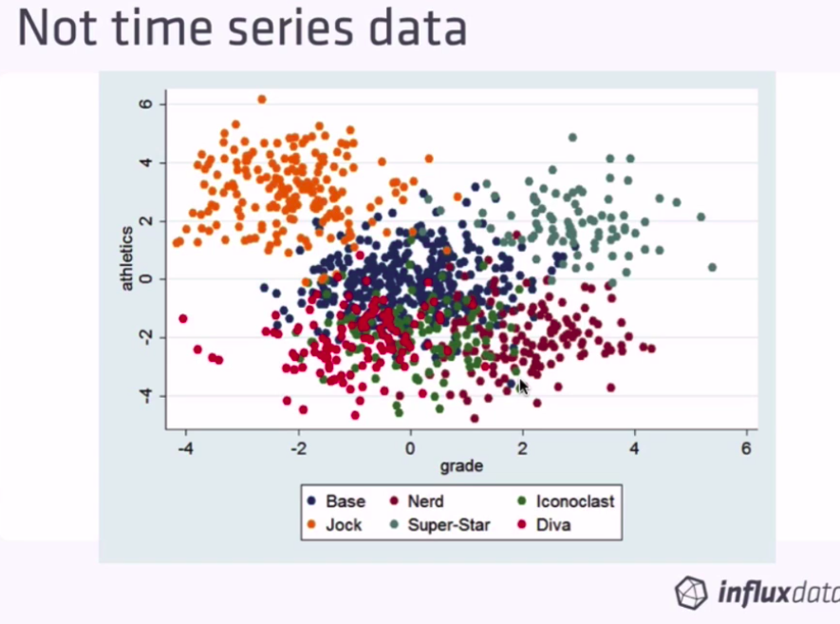

Problems with Relational Database for store time series:
- Relational Databases tend to grow slow with data due to ‘indexes’
- When you add new entries to your relational database, and if your table contains indexes, your database management system will repeatedly re-index your data for it to be accessed in a fast and efficient way.
- As a consequence, the performance of your DBMS tend to decrease over

Benefits of Time Series Data base:
1. Fast Ingestion Rate:
time. The load is also increasing over time, resulting in having difficulties to read your data.
- Time series database are optimized for a fast ingestion rate. It means that such index systems are optimized to index data that are aggregated over time, as a consequence, the ingestion rate does not decrease over time and stays quite stable, around 50k to 100k lines per second on a single node

2. Data Retention:
- influx db takes care of dropping the data after certain time with a concept called retention policy

3. Continuous Queries
- We can also run Continuous Queries on live data to perform certain operations:
4. Visualizing and alerting:
- TSDB can be easily integrated with tools like graphana

Influxdb Concepts:

1. Database:
- Similar to database like a SQL db.
- In influxdb, a database is a collection of measurements (tables in SQL DB)
- A single influxdb instance can host multiple database.
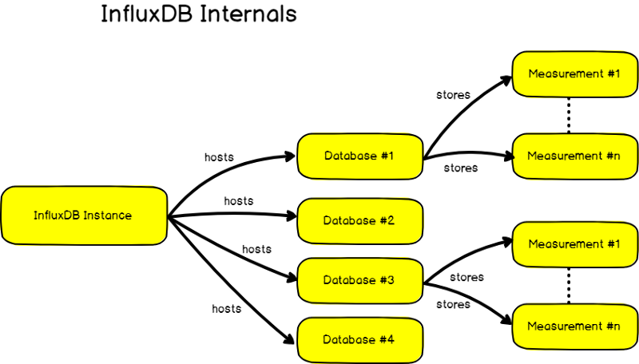
- To interact with the database, we have to first create it and then navigate to it.

2. Measurement:
- Likes tables in SQL.
- Stores data (and even meta data) over time.
- Data meant to coexist together should be stored in the same database

3. Tags and Fields:
- We have a choice to declare a new column either as a ‘tag’ or a ‘field’.
- ‘Tags’ are indexed and ‘fields’s are not
- Tags are like metadata defining our data in a measurement.
- They are hints giving additional information about the data, but not the data itself.

Note: Keep measurements relatively small when it comes to number of field.s

